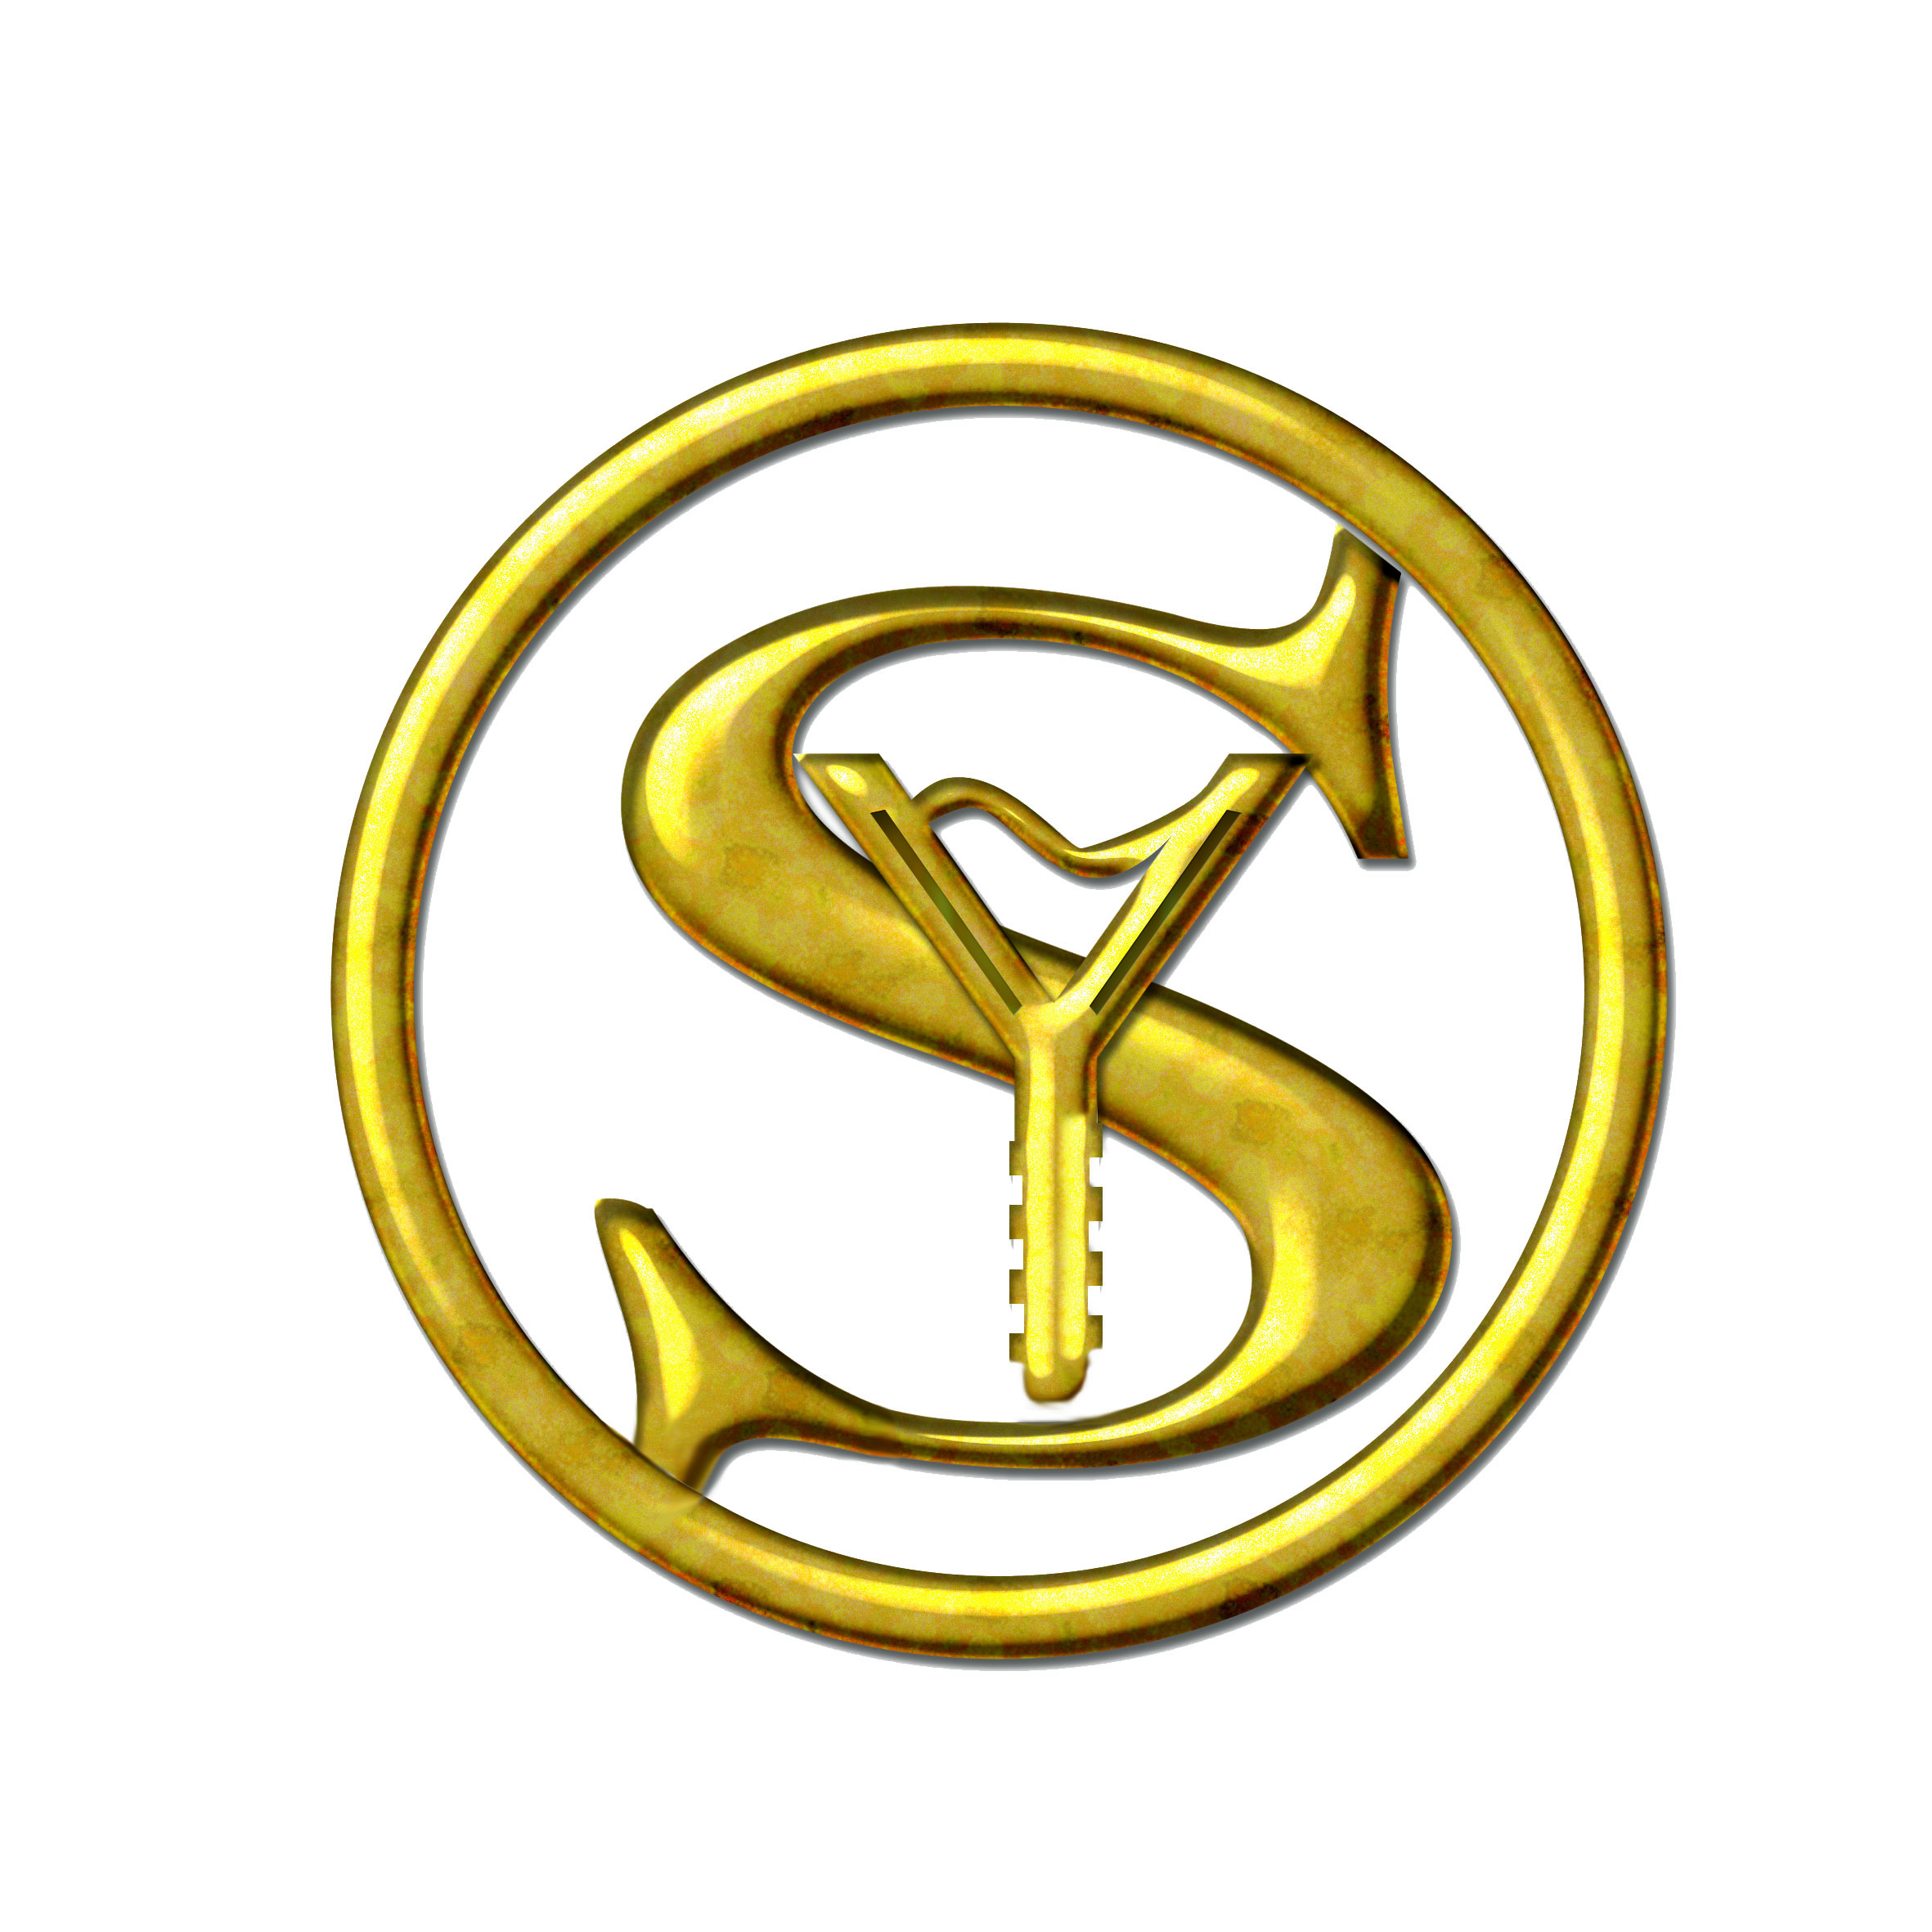ADVANCED DENTAL CARE CENTER

