**Dental Porcelain inlays and onlays**

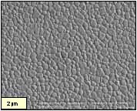**All Ceramic Dental Materials**

1. **Polycrystalline Ceramic**

* Glass free
* e.g: Lava ZrO2, Procera Al2O3
* σB = 500 - 1500 MPa
* KIC = 5 - 10

1. 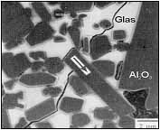**Infiltrated Ceramic**

* Glass containing
* e.g:InCeram Zirconia (≠ ZrO2), InCeram Alumina
* σB≤ 500 MPa
* KIC< 5 MPa m1/2

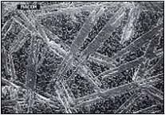

1. **Glass Ceramic**

* Glass containing
* e.g:Empress I/II
* σB≤ 400 MPa
* KIC = 2 - 3 MPa m1/2

**Zirconium Oxide Zr02**

* Outstanding mechanical properties
* >20 years of experience in various industrial   
  and medical applications
* Extremely low solubility and water sorption
* Consistant raw material properties
* Good availability of raw materials
* Known processing parameters of raw materials

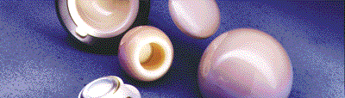

* Transformation toughening helps give zirconia its excellent mechanical properties:
* high flexural strength—900 MPa to 1.2 GPa—and
* toughness—7 to 8 MPa·m–0.5
* Good biocompatibility.
* Another approach is to mill a partially fired zirconia block.

Long-term Stability

* To guarantee successful, long-term multi-unit bridge restorations, an initial strength of more than 400 N is required for anterior restorations and more than 600 N for posterior applications.
* Currently, values such as these (e.g. Lava unit bridges: 1,500+N) are achieved only with alumina or zirconia bridges.
* Lava frame zirconia demonstrates no measurable solubility or water absorption.
* Limitations of glass ceramics and infiltrated ceramics (sub-critical crack growth, fatigues, stress, corrosion) when subjected to masticatory forces in the mouth are problematic.
* Generally speaking, the long-term strength of ceramic systems containing glass cannot be classified as risk free.
* Glass ceramics have a higher subcritical crack growth velocity and in consequence they have a lower long term stability due to the effect of oral moisture and sub-critical crack propagation (decreases to >50% of initial strength).

**Transformation Toughening of Zr02**

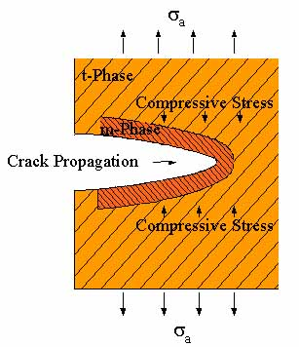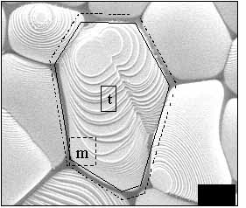

Fracture Mechanics - Zr02 Longevity

Flexural strength decreases through defects, crack propagation and crack corrosion.

**DIN 843 - 3**

|  |  |  |
| --- | --- | --- |
|  | sinitial  [MPa] | [MPa] |
| Lava | 1345 | 615* |
| Empress II | 289 | 82 |
| Cerec  (Mark II) | 88 | 32 |
| InCerAl | 666 | 125 |



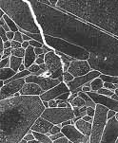

Strength Properties - Zr02

*ISO 6872* - Flexural Strength*

**Optical Properties of Ceramics**

Translucency comparison as a function of wall (coping) thickness



**Geometry Preparation Comparisons**

Lava:

* + Chamfer prep
  + Wall thickness 0.5 mm

In-Ceram:

* + Chamfer prep
  + Wall thickness 0.8mm

Empress:

* + Shoulder prep and overall reduction
  + 1.0 mm

Procera Alumina:

* + Prep
  + Wall thickness 0.6 mm

**Classification of ceramics**

1. Based on chemical composition

2. According to type

3. According to use

4. According to firing temperature

5. According to firing technique

6. According to substrate metal

7. Micro structural classification

8. Processing technique

1. **Based on Composition**
   1. Silicate ceramics
   2. Oxide ceramics
   3. Non-oxide ceramics
   4. Glass ceramics

**A) SILICATE CERAMICS:**

* Characterized by an amorphous glass phase with porous structure.
* The main components are SiO2 with small addition of crystalline Al2O3, MgO, ZrO2 and or other oxides.
* Dental porcelain falls in this category.

**B) OXIDE CERAMICS:**

* Contain principal crystalline phase (e.g., Al2O3, MgO, ThO2 or, ZrO2) with either no glass phase or a small content of glass phase.

**C) NON OXIDE CERAMICS:**

* These are impractical for use in dentistry because of high processing temperatures, complex processing methods or unaesthetic color and opacity.

**D) GLASS CERAMICS:**

* These are types of ceramics containing a glass matrix phase and at least one crystal phase.

**2. According To Type:**

a) Feldspathic porcelain

b) Leucite reinforced porcelain

c) Aluminous porcelain

d) Glass infiltrated aluminous

e) Glass infiltrated spinell

f) Glass ceramics

**3. According To Use:**

a) Ceramic for artificial teeth

b) Jacket crown, inlay and onlay ceramic

c) Metal ceramic

d) Anterior bridge ceramic

**4. According To Firing Temperature:**

a) High fusing - >1300 C

b) Medium fusing - 1101 t0 1300 C

c) Low fusing - 850-1101 C

d) Ultra low fusing - <850 C

**5- According To Firing Technique**

1. Air fired (at atmospheric pressure)

2. Vacuum fired (at reduced pressure)

3. Diffusible gas firing

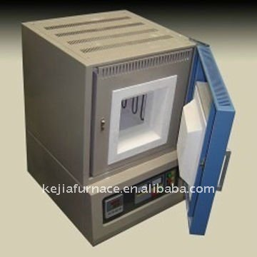

**6- According To Substrate Metal**

1. Cast metal

2. Sintered metal

3. Swaged metal

4. Glass ceramics

5. CAD/CAM

**COMPOSITION OF CERAMICS**

1. **HIGH FUSING PORCELAINS**

* Traditionally, the basic ingredients of these types of porcelains are feldspar, kaolin (clay) and quartz.

**Feldspar**

* It is the primary constituent, and all porcelains based on feldspar are referred to as *FELDSPATHIC PORCELAINS.*
* Natural feldspars can be either sodium feldspar (albite) or potassium feldspar (orthoclase / microline) which are minerals composed of potash (K2O), Soda (Na2O) Alumina (Al2O3) and silica (SiO2).
* These are necessary to increase the thermal expansion compatible with metal coping.
* Feldspars are present in concentrations of 75 to 85% and undergo incongruent melting at temperatures between 1150°C and 1530˚C.
* Incongruent melting is the process by which one material melts to form a liquid plus a different crystalline material.
* Hence a glassy phase is formed and suspended inside it are crystalline potassium alumino silicate crystals known as Leucite.

**KAOLIN / CLAY**

* Kaolin / clay (Al2O3, 2SiO2, 2H2O) serves as a binder.
* When mixed with water, it forms a sticky mass, which allows the unfired porcelain to be easily worked and molded.
* On heating, it reacts limitedly with feldspar (known as pyrochemical reaction) and thereby provides rigidly.
* It also adheres to the framework of quartz particles and shrinks considerably during firing.

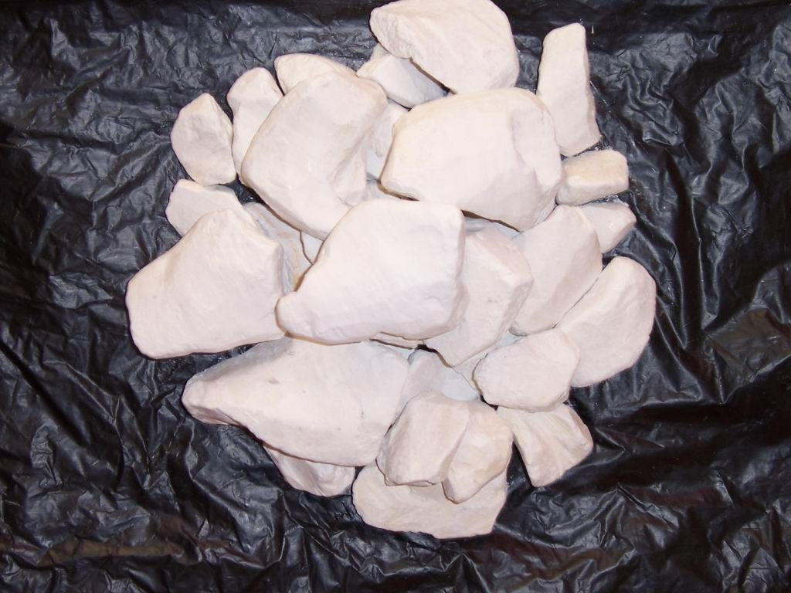

**PURE QUARTZ**

* Pure quartz is used porcelain as a strengthener.
* The main function of quartz (silica) is to impart more strength and firmness, and a greater translucency.
* Silica remains unchanged at the usual firing temperatures and hence contributes stability to the mass during heating by providing a framework for other constituents.

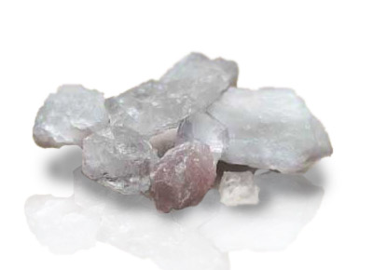

**MEDIUM, LOW AN ULTRA LOW FUSING PORCELAINS**

* The low and medium fusing porcelain powders are glasses which have been ground from blocks of matured porcelain.
* For this, the raw ingredients are mixed and fused, and the fused mass is then quenched in water.
* The rapid cooling induces stresses in the glass to the extent that considerable cracks and fractures occur.
* This process is referred to as FRITTING and the product so obtained is called a frit.
* The brittle material is then ground to a fine powder of almost colloidal dimensions.
* During subsequent firing, little or no pyrochemical reaction occurs, but the glass phase softens and flows slightly. This softening allows the powder particles to coalesce together (sintering) and form a dense solid.
* However, the temperature must be controlled to minimize the pyroplastic flow.
* The raw ingredients for the low and medium fusing porcelains are basically the same as for the high fusing porcelain powders but in addition contain balancing oxides / fluxes.
* These additions tend to modify the properties by interrupting the glass network and hence are also known as glass modifiers.

**GLASS MODIFIERS**

* The most commonly used glass modifiers are potassium, sodium and calciumoxides.
* These are introduced as carbonates that revert to oxides on heating.
* Other oxides added are lithium oxide, magnesium oxide, and phosphorous pentoxide .

**INTERMEDIATE OXIDES:**

* To overcome the problem of decreased viscosity ; intermediate oxides like aluminium oxide (Al2O3), are added

**BORIC OXIDE**

* Boric oxide (B2O3) serves as a glass modifier as well as a glass former i.e.
  + Decrease its viscosity,
  + Lowers softening temperature
  + Forms own glass network

**OPACIFYING AGENT**

* The translucency of porcelain can be decreased by using an opacifying agent.
* An opacifying agent is generally a metal oxide-ground to a very fine particle size of <5m m.
* Zirconium oxide is the most common opacifiers
* The difference between the refractive indices of the glass and the opacifiers is the basic mechanism behind opalescence.
* Different wave length of visible light are scattered differently by the opacifying particles.
* This effect depends upon the size as well as the volume distribution of the particles.

**COLOURING AGENTS**

* Pigmenting or colouring oxides are added to obtain various shades needed to simulate natural teeth.
* These pigments are produced by fusing metallic oxides together with fine glass and feldspar and then regrinding to a powder.
* This powder is blended with the un-pigmented porcelain powder to obtain the proper hue and chroma.

**STAINS AND COLOR MODIFIERS**

* Stains are generally low fusing colored porcelains used to imitate markings like enamel check lines, calcification spots, fluoresced areas etc.
* Stains in finely powdered form are mixed with water or glycerine and water or any other special liquid.
* The wet mix is applied with a brush either on to the surface of porcelain before glazing, or built into the porcelain (internal staining).
* Internal staining is preferable as it gives more lifelike results and also prevents direct damage to the stains by the surrounding chemical environment.
* Color modifiers on the other hand are less concentrated than stains and are used to obtain gingival effects or highlight body colours, and are best used at the same temperature as the dental porcelain.

**Ceramic nano-powders**

* Nanotechnology has enabled the preparation of nanopowders from zirconia-based ceramic (ZrO2), alumina (Al2O3) and ceria (CeO2).
* The resulting nanopowders have been used in the manufacture of industrial ceramic blocks for machining.
* With the introduction of these powders, the resulting block has a smooth surface; there is a considerable reduction of porosity and internal defects, and increased flexural strength (Yang et al., 2009).
* The optical properties have also been benefited because, as the nano-sized particles are well below the wavelength of light, they allow light to pass through the material.
* As handmade ceramics based on alumina and zirconia showed a high opacity; with the introduction of ceramic nanopowders, the current structural ceramics have begun to show an opacity subjected to laboratory control (Manicone etal., 2007).

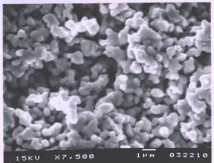

*Conventional powder slurry ceramic*

**ALUMINA REINFORCED PORCELAIN**

* It was introduced by McLean and HUGES in 1965, to improve strength by prevention of crack propagation.
* These are based on the principle of dispersion strengthening i.e. dispersing alumina Crystals of high strength and elasticity in a glass matrix.
* A core structured is formed that has increased flexure Strength, elasticity and fracture toughness compared to conventional porcelains.
* For dental purpose single crystals of alumina are preferred over fine powdered alumina, to avoid excessive opacity which occurs because of difference in the refractive index of glass porcelain and alumina crystals.
* Glass used for incorporating alumina crystals is BOROSILICATE GLASS Containing:
  + Silica
  + Alumina
  + Potash Soda Lime
  + Boric acid
* Strength and opacity of aluminous porcelain is dependent on alumina crystal: Size, Shap& Concentration
* Commercially available product is **Hi-Ceram (Vita).**
* Uses:
  + Forming refractory framework capable of supporting weaker, more translucent Dentin and enamel Porcelain.

**LEUCITE REINFORCED PORCELAIN**

* Commercially available as OPTEC HSP
* Leucite conc. is:50.6 %
* These porcelains contain dispersed LEUCITE {potassium alumino-silicates} in glassy Matrix. Therefore more stronger than conventional Feldspathic porcelains.
* Because of its increased strength it does not require core when used to fabricate all ceramic Restoration as is necessary with aluminous porcelain PJCs.
* The buildup, condensation and contouring is done using powder slurry technique on special semi permeable die material.
* **Uses:**

Used both for incisal and body portions being more aesthetics

* **Advantages:**
  + Lack of metal or opaque substructure, good translucency
  + Moderate flexure strength, higher than conventional Feldspathic porcelains
  + Ability to be used without any special lab equipments
* **Disadvantages:**
  + Margins inaccuracy caused by porcelains sintering shrinkage Potential to fracture in posterior teeth
  + High wear of opposing tooth due to high Leucite content

**DUCERAM Low Fusing Ceramics :**

* Also known as hydrothermal low fusing ceramics.
* It is a low fusing ceramic, composed of an amorphous glass containing hydroxyl ions
* *Properties*: (compared to Feldspathic porcelain)
  + - Greater density
    - Higher flexure strength
    - Greater fracture resistance
    - Lower hardness
* Restoration from Duceram LFC is made in 2 layers:
  + - The base layer is Duceram metal ceramics (Leucite containing porcelain) which is placed on refractory die using powder slurry technique and then baked at 930 C.
    - Duceram LFC is applied using powder slurry technique and then baked at 660 C.
* Available in variety of shades and can be characterized by variety of stains and modifiers.
* USES:
  + - Ceramics inlays, veeners, and full contour crowns

**INFILTERED CERAMICS (IN-CERAM)**

* Developed INCERAM in 1985
* In-ceram is supplied as one of the three core ceramics:
* *In-ceram spinnel, In-ceram alumina, In-ceram zirconia*

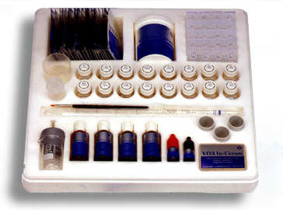

* **INDICATION:**
* **In-ceram spinnel:**
  + Anterior single unit inlays,onlays crowns and veeners.
  + In clinical situations where maximum translucency is needed
* **In ceram alumina:**
  + Anterior and posterior crowns
  + Anterior 3 unit FPD
* **Inceram zirconia:**
  + Because of high strength and fracture toughness it is indicated for posterior crowns and FPD

**CASTABLE GLASS CERAMIC**

* The first commercially available castable ceramic material for dental use, DICOR, was developed by corning glass works and marketed by Dentsply international**.**
* **Classification of Castable Dental Glass Ceramics:**
  + Flucoromicas Dicor
  + Apatite glass ceramics pearl
  + Other glass ceramics Lithia ,Calcium Phosphate
* **PRESSABLE GLASS CERAMIC**
  + IPS empress
* **Optec pressable ceramics**
  + A glass ceramics is material that is formed into desired shape as a glass, and then subjected to a heat treatment to induce partial devitrification (that is loss of glassy structure by crystallization of the glass).
  + The crystalline particles, needles or plates formed during this ceramming process serve to interrupt the propagation of the cracks in the material when intraoral force is applied, causing increased strength and toughness**.**